**Excel Assignment – 7**

**1. Using Insert Function, give examples of any function available in the**

**different dropdowns present in the function library. For example**

**AutoSum, Recently Used, Text, Date & Time, etc.**

Click on ‘fx’ in the *Formula Quick Menu.*

Insert Function window will appear. There all the functions are divided into different category

1. **Most Recently Used**

* **MAX:** Finds the maximum value in a range of cells

1. **Financial:**

* **EFFECT**: Returns the effective annual interest rate.

1. **Date & Time**

* **NOW**: The NOW() function in Excel gives the current system date and time.
* **TODAY**: The TODAY() function in Excel provides the current system date.
* **TIME**: The TIME() function converts hours, minutes, seconds given as numbers to an Excel serial number, formatted with a time format.

1. **Math & Trig**

* **SUM** : The SUM() function, as the name suggests, gives the total of the selected range of cell values

1. **Statistical**

* **AVERAGE**: The AVERAGE() function focuses on calculating the average of the selected range of cell values

1. **Lookup & Reference**

* **VLOOKUP**: VLOOKUP() function stands for the vertical lookup that is responsible for looking for a particular value in the leftmost column of a table. It then returns a value in the same row from a column you specify.

1. **Database**

* **DAVERAGE**: Averages the values in a column in a list or database that match conditions you specify.

1. **Text**

* **LEN**: The function LEN() returns the total number of characters in a string. So, it will count the overall characters, including spaces and special characters.

1. **Logical**

* IF: The IF() function checks a given condition and returns a particular value if it is TRUE. It will return another value if the condition is FALSE.

1. **Information**

* **ISNA, ISEVEN, ISODD, ISNUMBER, ISNONTEXT, ISTEXT**

All these function check whether a value is (#N/A, even, odd, number, not text, text), and return TRUE or FALSE.

1. **Engineering**

* **BIN2DEC**: Convert a binary number to decimal.

**2. What are the different ways you can select columns and rows?**

**Select a Single Row/Column**

1. Bring the cursor over the row number of the row that you want to select
2. Use the left mouse-click to select the entire row

When you select the entire row, you will see that the color of that selection changes

Just like we have selected a row, we can also select a column.

**Select Multiple Rows/Columns**

1. Place the cursor over row number at one of the edge of the selection.
2. Press the mouse left button while your cursor is on that row number (keep the mouse button pressed)
3. Keep the mouse left-button still pressed and drag the cursor down till opposite edge.
4. Leave the mouse button.

**Select Multiple Non-Adjacent Rows/Columns**

For example, you may want to select row numbers 2, 4, 7.

1. Place the cursor over row number 2 in the worksheet
2. Hold the Control key on your keyboard
3. Press the mouse left button while your cursor is on row number 2
4. Leave the mouse button
5. Place the cursor over the next row you want to select (row 4 in this case),
6. Hold the Control key on your keyboard
7. Press the mouse left button while your cursor is on row number 4. Once row 4 is also selected, leave the mouse button
8. Repeat the same to select row 7 as well
9. Leave the Control key

**3. What is AutoFit and why do we use it?**

Excel's AutoFit feature is designed to automatically resize cells in a worksheet to accommodate different sized data without having to manually change the column width and row height.

**AutoFit Column Width**- changes the column width to hold the largest value in the column.

**AutoFit Row Height** - adjusts the column width to match the largest value in the row. This option expands the row vertically to hold multi-line or extra-tall text.

**4. How can you insert new rows and columns into the existing table?**

Insert a Row or Column within a Table

1. Select a cell in the table row or column next to where you want to add the row or column.

**Note**: Insert options aren’t available if you select a column header.

1. Click the Insert list arrow on the Home tab.
2. Select an insert table option.

* Insert Table Rows Above: Inserts a new row above the select cell.
* Insert Table Columns to the Left: Inserts a new column to the left of the selected cell.

**5. How do you hide and unhide columns in excel?**

**Hide columns**

1. Select one or more columns, and then press Ctrl to select additional columns that aren't adjacent.
2. Right-click the selected columns, and then select **Hide**.

**Note:**The double line between two columns is an indicator that you've hidden a column.

**Unhide columns**

1. Select the adjacent columns for the hidden columns.
2. Right-click the selected columns, and then select **Unhide**.

**Using Keyboard Shortcuts**

Ctrl + 0 = To hide a Column

Ctrl + Shift + 0 = To Unhide a column

**6. Create an appropriate table within the worksheet and use different**

**functions available in the AutoSum command.**

I have used the below table as shown in the screenshot.

For Average in the Autosum Function, the function number used is 109

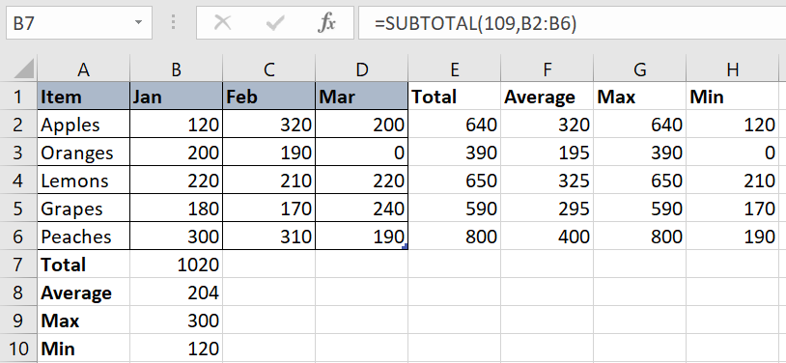

For Max in the Autosum Function, the function number used is 104

